ENGLISH NOTES
Fifth module

What is an oral presentation?
Oral presentations, also known as public speaking or simply presentations, consist of an individual or group verbally addressing an audience on a particular topic. The aim of this is to educate, inform, entertain or present an argument. Oral presentations are seen within workplaces, classrooms and even at social events such as weddings. An oral presentation at university assesses the presenter’s ability to communicate relevant information effectively in an interesting and engaging manner.

Group presentations
In some instances, you may be required to present as part of a group to test your ability to work as a member of a team. Working within a group can sometimes be a challenge or a great success. To understand how to effectively work in a group, take a look at our Group Work resource.

TIPS
- Divide the topic of your presentation into subtopics, and allocate one to each group member. Doing this will ensure that the workload is evenly shared and that everyone takes part in the assessment.
- Rehearse together as a group. Although it may seem easy for each group member to go off and cover their own section alone, not having regular group meetings or rehearsals will cause your presentation to appear disjointed.
- Ensure the presentation is consistent by using a consistent style for your visual aids. If the visual aids your group uses are not consistent in format, colour and font styles, it will be clear to the marker that you have not been working as a team.
- Use a cloud-based service or platform to create your presentation. Most cloud-based services and platforms have functions that allow you to work on materials remotely from one another. Check out our digital presentation resources to learn more.

Planning and presenting an oral presentation

Planning your oral presentation
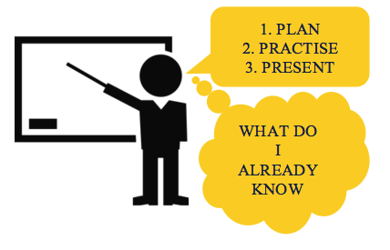 The most important factors for a successful presentation are: careful planning, lots of practice and engaging the audience. It's a good idea to watch some professional presentations online to get a sense of what good speakers do.
- Review the subject outline. Look for all relevant detail that you will need to understand the requirements of the task, including when it is due, the weight of the assessment, and the length of time you have to present. Review the assessment criteria. What are you are being assessed on?
- Analyse the task. Determine the purpose of the presentation. Do you need to answer a specific question?
- Consider the audience. What are their expectations of your content and delivery?
- Brainstorm. Map out everything you already know about the topic. Write out any ideas you can use to interact with the audience, or engage them, and jot down what questions, explanations and information you want the audience to be provided with.
- Do the research. Find relevant material, take notes, and remember to keep the references you used.
- Organise your ideas. Create a logical presentation so the information flows well.
- Pay attention to the language you are using. Presentations should be delivered in spoken or conversational language rather than written language. Spoken language is much easier for your audience to follow.

Image transcription
- What do I already know?
- Plan
- Practice
- Present
Audience interaction and engagement
Even if it isn’t a specific requirement, it is good practice to engage the audience and/or to have them interact during your presentation. Examples of ways to ensure audience interaction are:
- Asking questions, testing the audience, providing a quiz.
- Allowing the audience to ask questions.
- Providing handouts – consider a ‘fill in the blank’ document that goes hand-in-hand with a slideshow or the information you are presenting.
- Asking someone to volunteer if there are demonstrations.
- Providing small gift bags with information and some lollies.
Using visual aids
In many oral presentation assessments you will be allowed or required to use visual aids, such as slides, images or props, to add an interesting feature and engage the audience. Keep your visual aids clear and to the point, and ensure that they are easily readable by your audience.Preparing to present
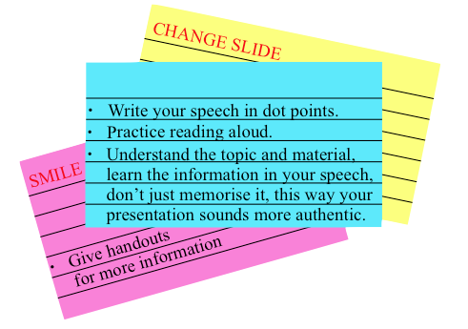 Once you have completed writing your presentation – remember, this needs to sound like spoken language, not written language! - and have finalised your visual aids, it is time to practice the presentation. When practicing your speech consider these aspects:
- Speak slowly and clearly.
- Don’t read off your palm cards.
- Maintain eye contact with the audience.
- Maintain good posture so you can be clearly heard.
- Use natural hand gestures.
- Use a natural tone of voice.
- Practice to improve your confidence.
- Practice pronunciation of difficult words by breaking them into syllables.
- Be mindful of your body language.
- Time yourself to make sure you are within the time limits.
It is also important that you use this time to make sure that you are fully prepared. Do you need to collect props? Have you thought about how you will access your visual aids?

Image transcription
- Write your speech in dot points
- Practice reading aloud
- Understand the topic and material, learn the information in your speech, don’t just memorise it, this way your presentation sounds more authentic
- Remember to smile
- Give handouts with more information

On the day of your presentation
On the day of your presentation, you might feel anxious or nervous and that is completely normally. Have confidence in your ability, the presentation you have planned, and the preparation you have done!
EXTEMPORE
  - An extempore speech is an impromptu speech which the candidate is required to make on a topic given there and then. No prior preparation is permissible.
  - An extempore presentation tests the candidate on the following:-
    - Ability to think off the feet : Since the candidate is required to speak on the spur of the moment, it gauges the candidate’s ability to think, organize and speak there and then.
    - Analysis of the topic and identification of the issue to be addressed : An extempore has a huge probability of going in a random and directionless manner if proper analysis does not precede the speech. The candidate is advised to understand the key issues which need to be addressed and then logically position them to create a coherent and well knitted presentation.
    - Idea generation : The biggest challenge in an extempore speech is to come out with a quick sequence of ideas. This assumes even stronger proportions because of limited time available for the task.
- Prioritization and sequencing to display logical thinking :The challenge is not just to speak under time pressure, but also to make logical sense through systematic and rational listing of ideas. This becomes even more critical if the topic is an abstract one and hence dependent on one’s perception.
- Ability to connect with the panel : Conventionally, the time available for an extempore presentation ranges from one to five minutes. In this limited time span, the candidate is expected to do justice to the topic, which is more likely to happen if he connects well with the panel.
- Communication skills : These are important as the effectiveness of the presentation is critically determined by communication skills – both verbal and non-verbal. While articulation, fluency and modulation are key determinants of verbal effectiveness; energy, eye contact and gestures mark the efficacy of non-verbal connect.
- Overall presentation skills- like body language, confidence, poise & composure – also have an important role to play in enhancing the quality of the extempore speech

Mental Preparation
- Know what to speak before delivering speech. Ponder over the topic for some time and prepare the flow of delivery. Your previous extempore practice sessions would surely help here.
- Understand the audience - the direction they are most likely to accept, helps in framing the flow of speech.

ontrol on speech
- Don't get emotional about the respective topic, avoid getting too personal on sensitive matters and don't deviate from the topic.
- For a satisfactory performance, it is always better to use your knowledge in an intelligent way with a control on the speech. Emotional attachment with the topic may be detrimental to the overall performance, as it may limit you to only dimension of the topic.

Presenting both sides
- Incase of controversial topics,the candidate may choose to explore both sides, a stand which becomes difficult to take in case of GDs due to challenges of group dynamics.
- In an extempore, since the candidate is the only person speaking, it becomes possible for a smart, strategic speaker to discuss both aspects of the controversial topic. However, one has to be careful about the time constraints while taking this stand.
- What is public speaking?
- 
- Public speaking, also called oration or oratory, is the process of communicating information to a live audience. The type of information communicated is deliberately structured to inform, persuade, and entertain. Many people fear they suffer from a public speaking weakness and lack the will to master the skill.

The Importance of Public Speaking
- Even if you don't need to make regular presentations in front of a group, there are plenty of situations where good public speaking skills can help you advance your career and create opportunities.
- For example, you might have to talk about your organization at a conference, make a speech after accepting an award, or teach a class to new recruits. Speaking to an audience also includes online presentations or talks; for instance, when training a virtual team, or when speaking to a group of customers in an online meeting.
- Good public speaking skills are important in other areas of your life, as well. You might be asked to make a speech at a friend's wedding, give a eulogy for a loved one, or inspire a group of volunteers at a charity event.
- In short, being a good public speaker can enhance your reputation, boost your self-confidence, and open up countless opportunities.
- However, while good skills can open doors, poor ones can close them. For example, your boss might decide against promoting you after sitting through a badly-delivered presentation. You might lose a valuable new contract by failing to connect with a prospect during a sales pitch. Or you could make a poor impression with your new team, because you trip over your words and don't look people in the eye.
- Make sure that you learn how to speak well!

